ER Diagram for this Project:

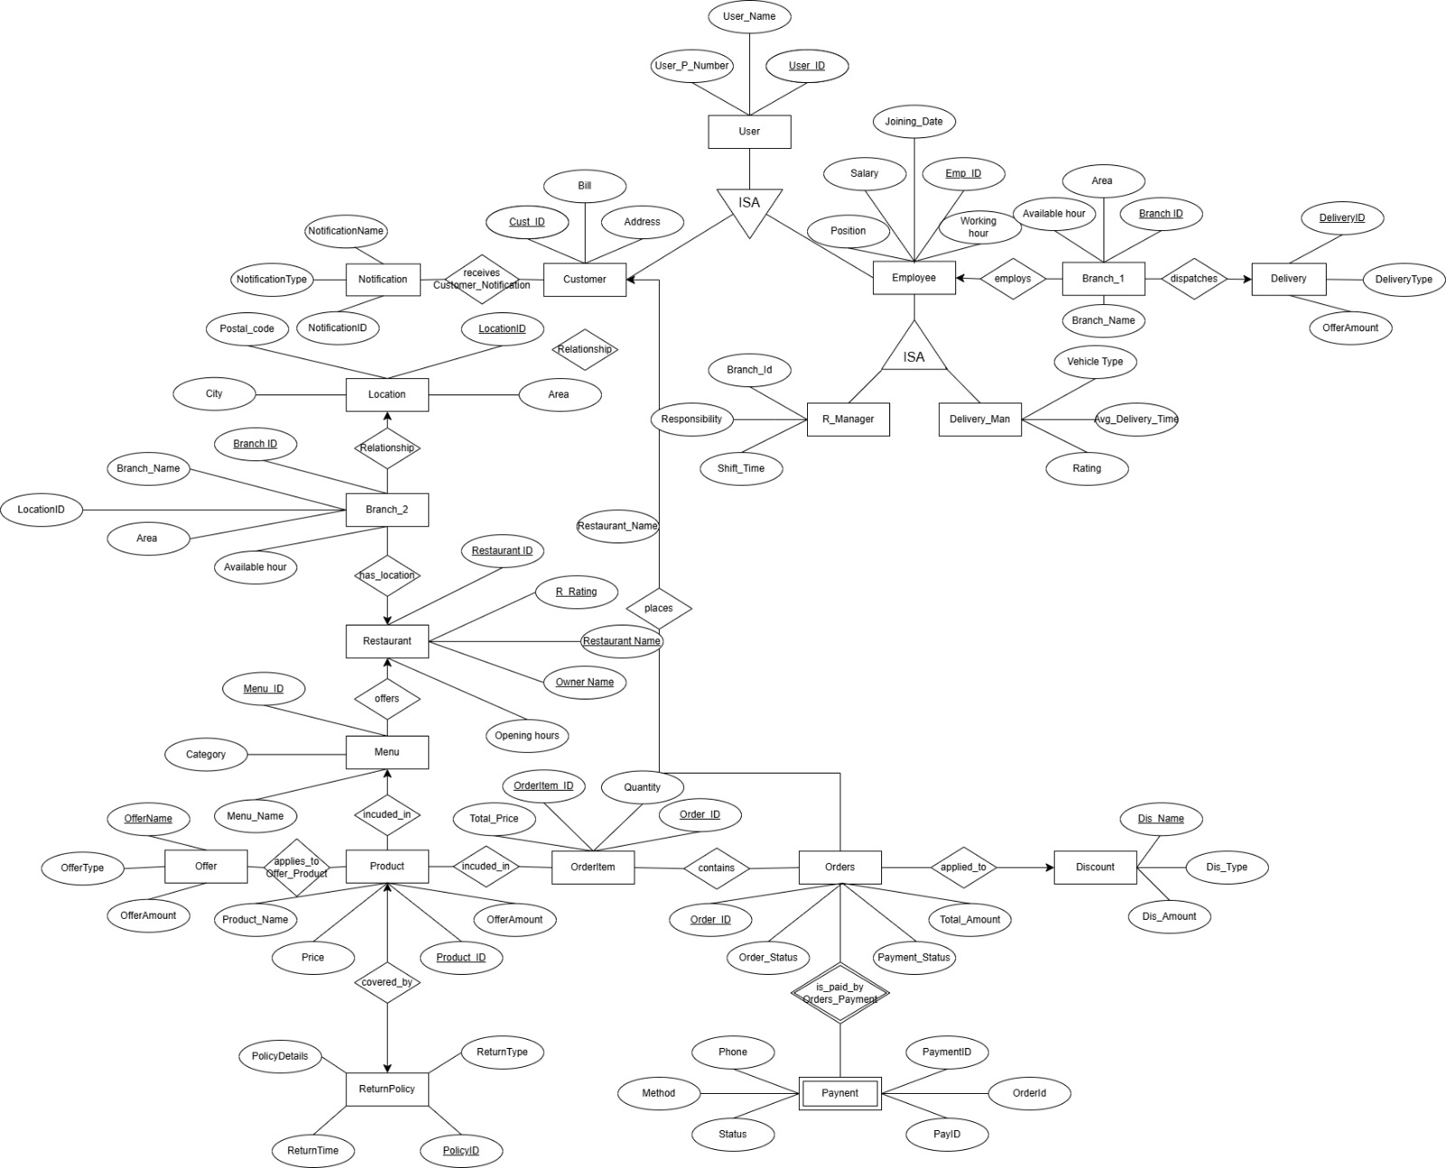

Schema Diagram:(Logical):
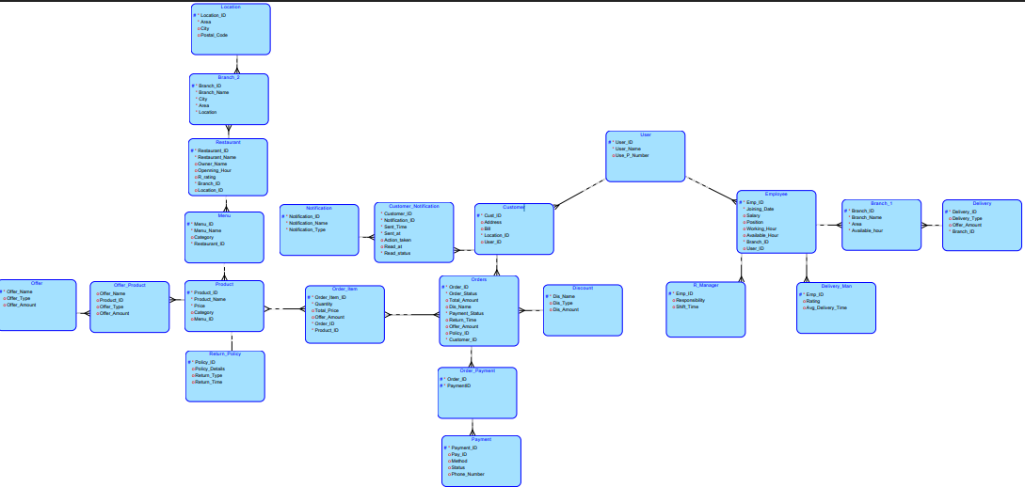
Schema Diagram:(Relational):
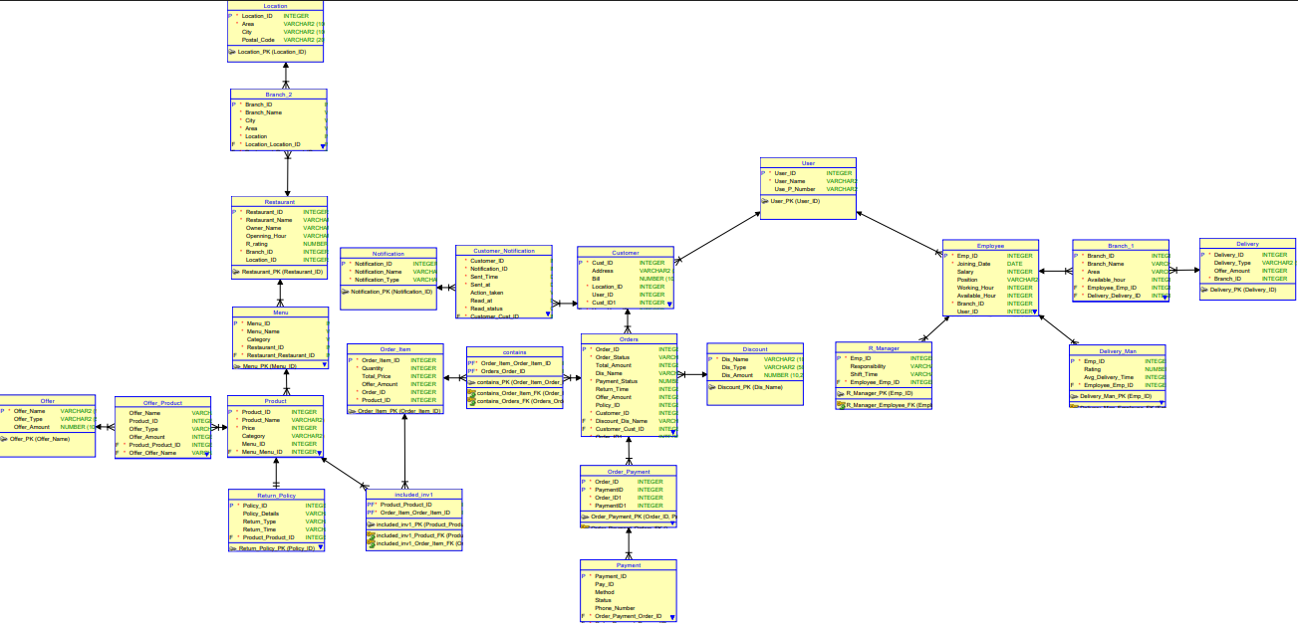

Table:
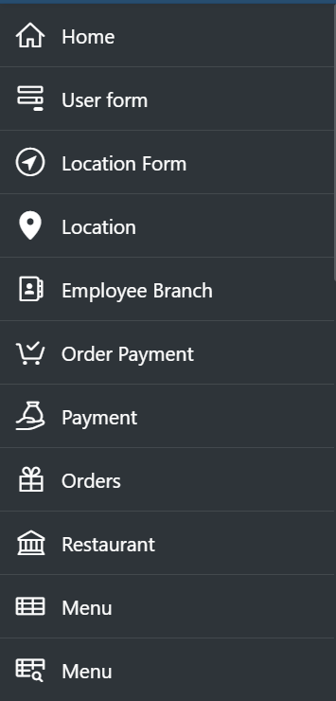
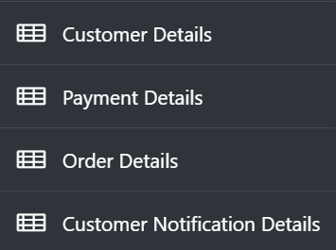
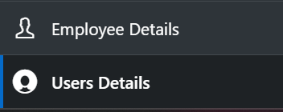

VIEW:
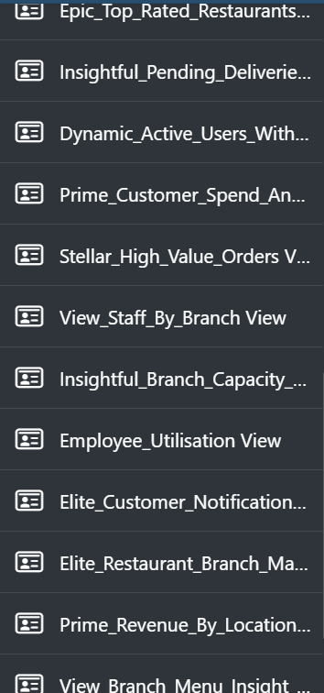

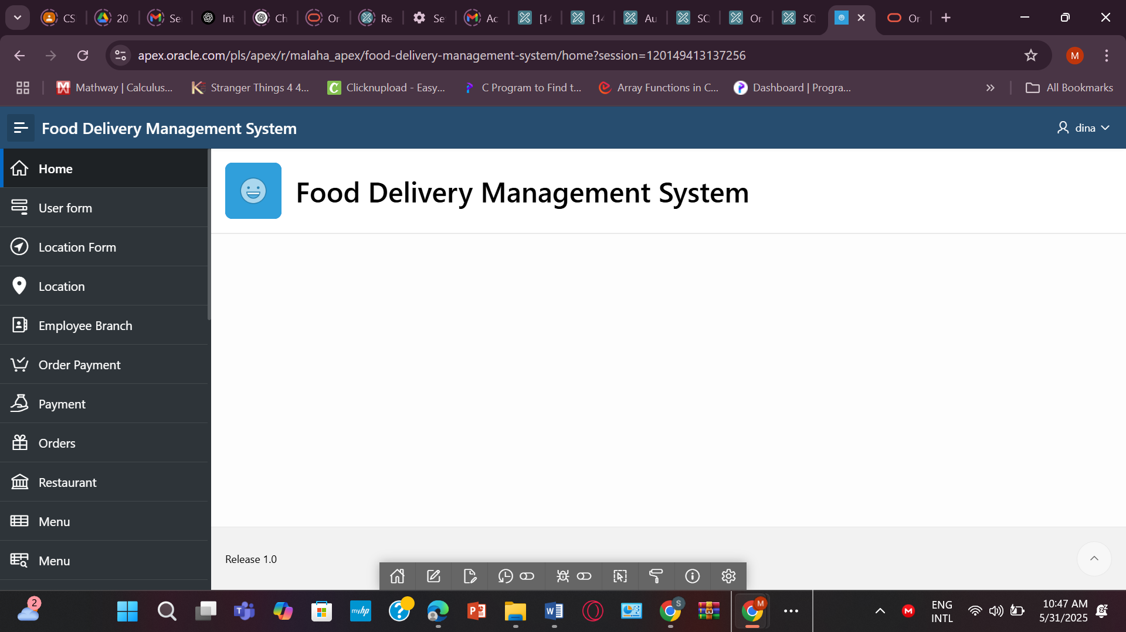

Tables :
- USER_
CREATE TABLE USER_ (
User_ID NUMBER PRIMARY KEY,
User_Name VARCHAR2(100) NOT NULL,
User_P_Number VARCHAR2(20)
);
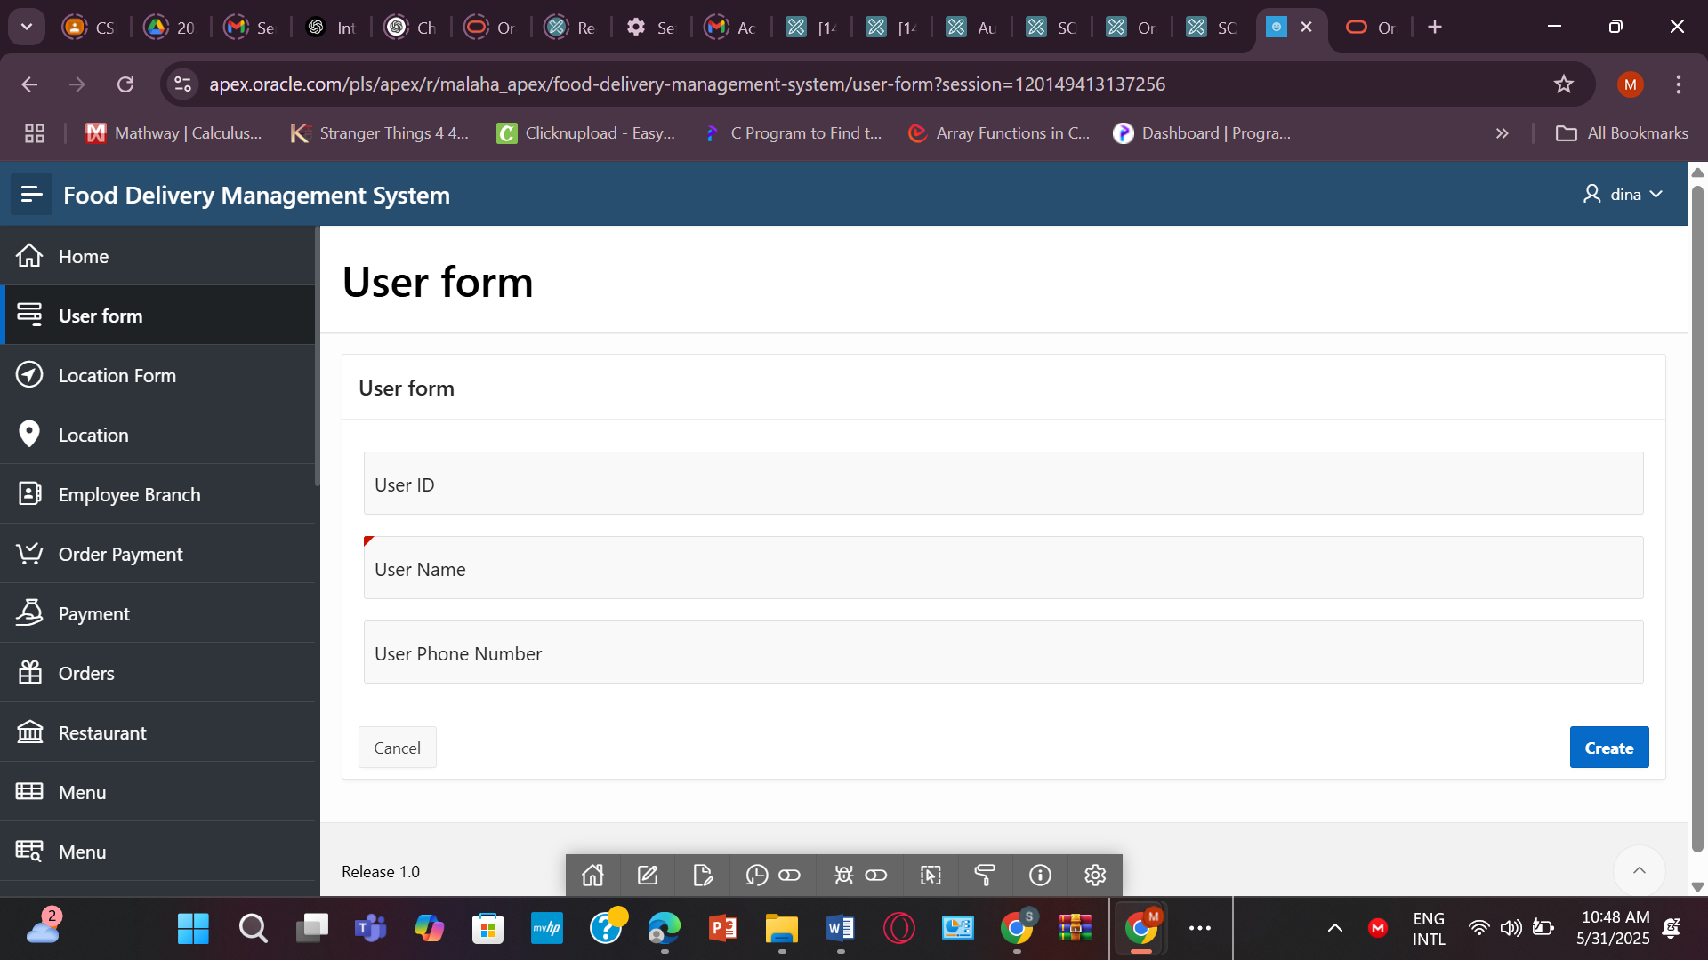

- LOCATION
CREATE TABLE LOCATION (
Location_ID NUMBER PRIMARY KEY,
Area VARCHAR2(100) NOT NULL,
City VARCHAR2(100),
Postal_Code VARCHAR2(20));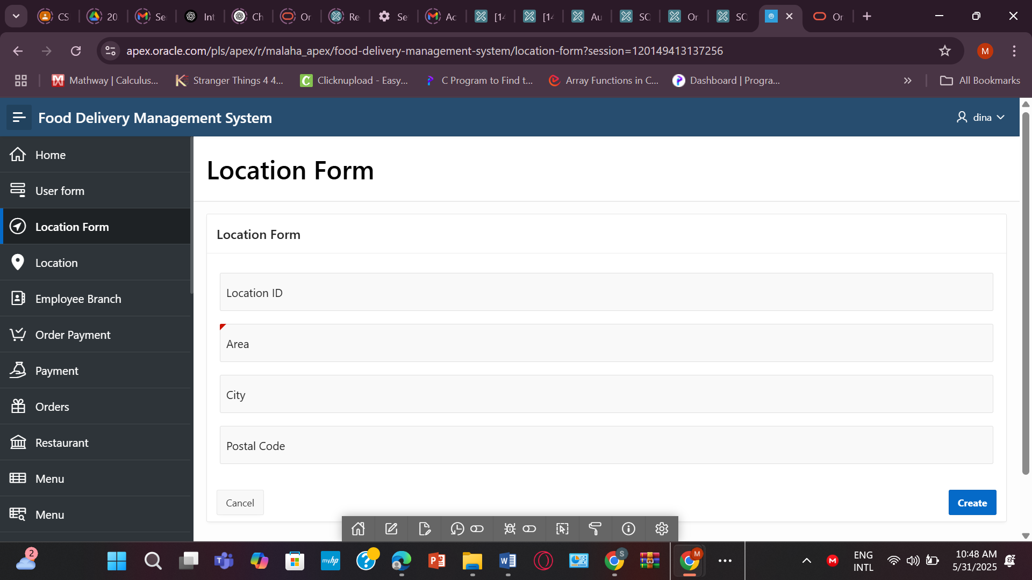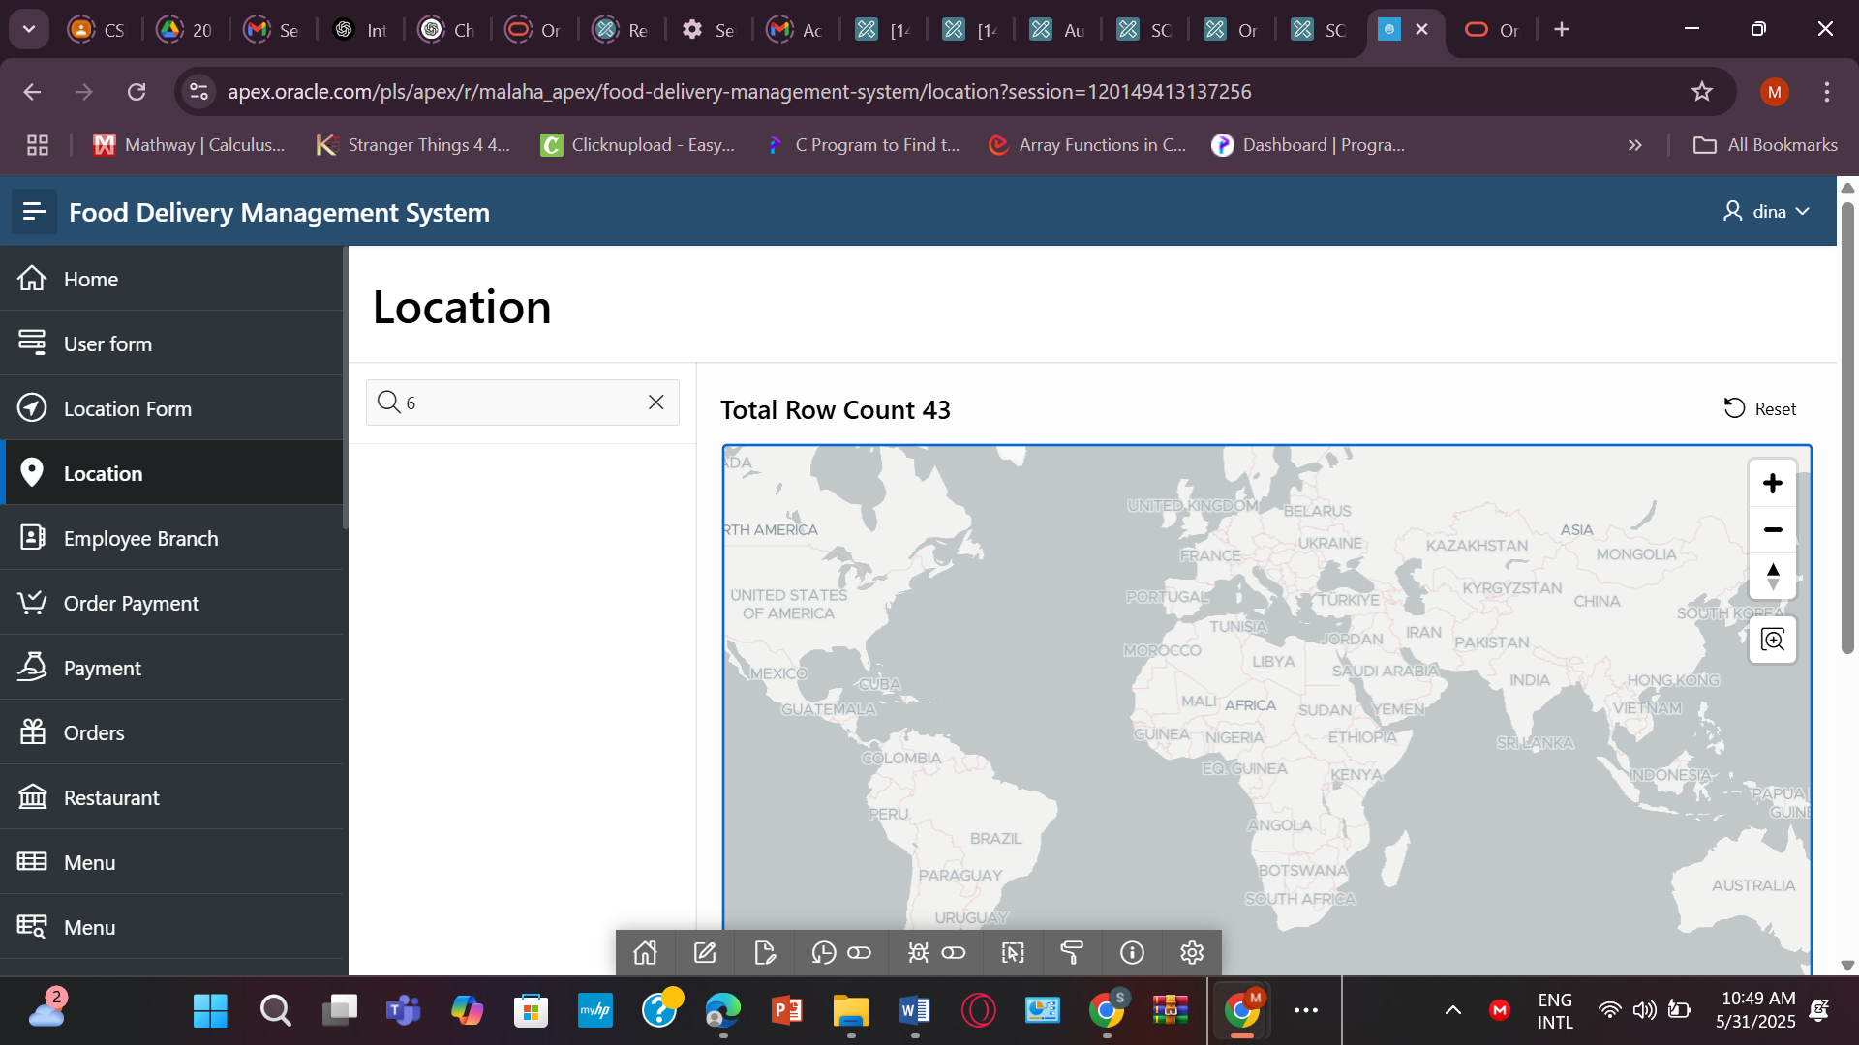
- EMPLOYEE
CREATE TABLE EMPLOYEE (
Emp_ID NUMBER PRIMARY KEY,
Joining_Date DATE NOT NULL,
Salary NUMBER(10,2),
Position VARCHAR2(50),
Working_hour NUMBER,
Available_hour NUMBER,
Branch_ID NUMBER NOT NULL,
User_ID NUMBER,
CONSTRAINT fk_emp_user FOREIGN KEY (User_ID) REFERENCES USER_(User_ID),
CONSTRAINT fk_emp_branch FOREIGN KEY (Branch_ID) REFERENCES BRANCH_1(Branch_ID)
);
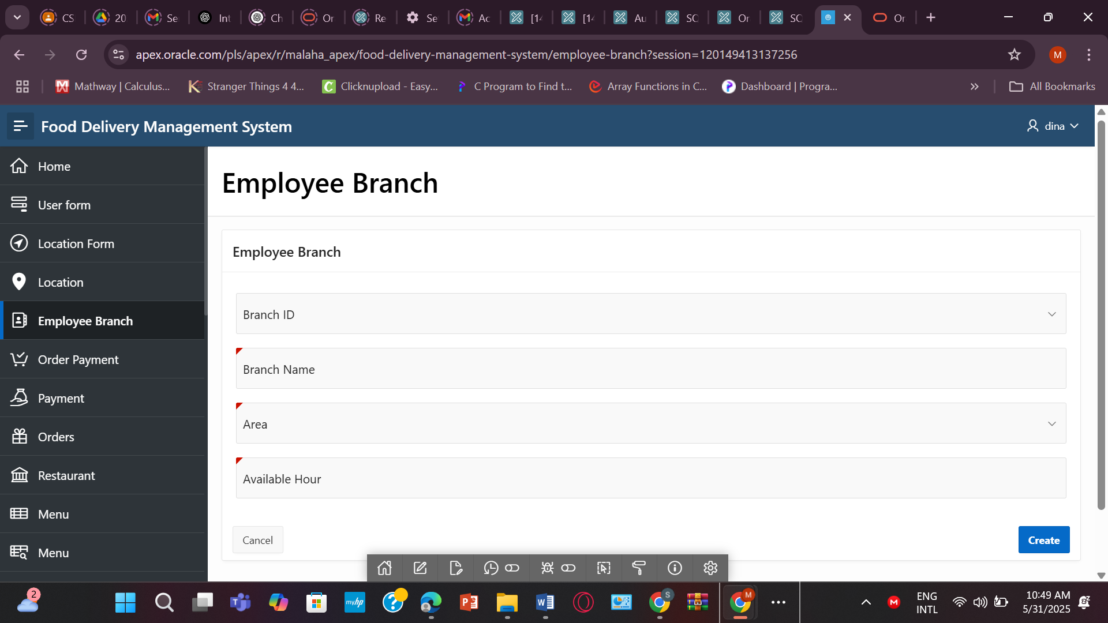

- ORDER_PAYMENT
CREATE TABLE ORDER_PAYMENT (
Order_ID NUMBER,
PaymentID NUMBER,
CONSTRAINT pk_order_payment PRIMARY KEY (Order_ID, PaymentID),
CONSTRAINT fk_order FOREIGN KEY (Order_ID) REFERENCES ORDERS(Order_ID),
CONSTRAINT fk_payment FOREIGN KEY (PaymentID) REFERENCES PAYMENT(PaymentID)
);
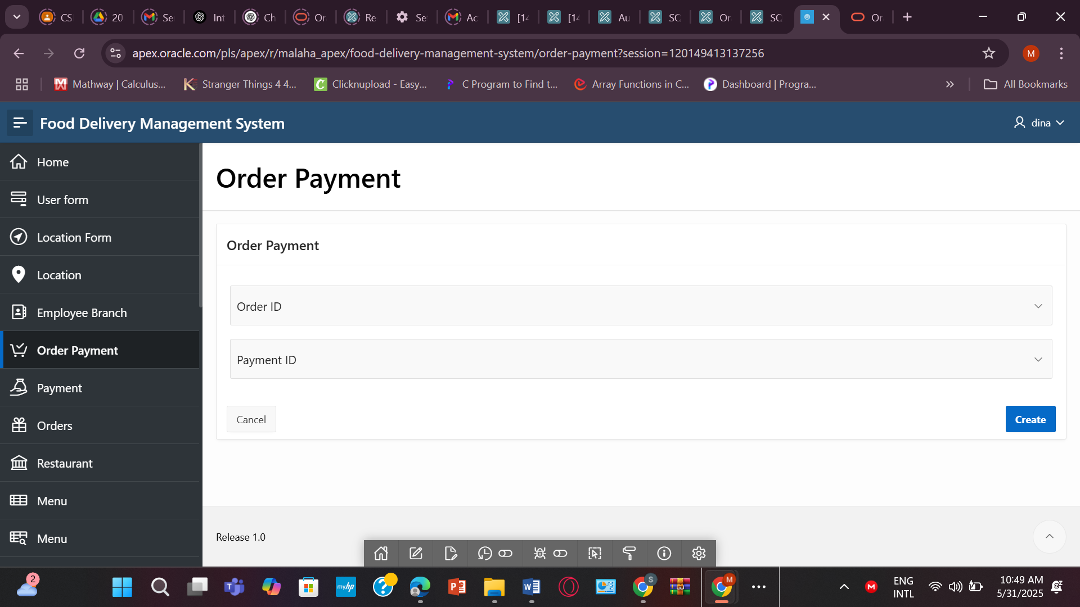
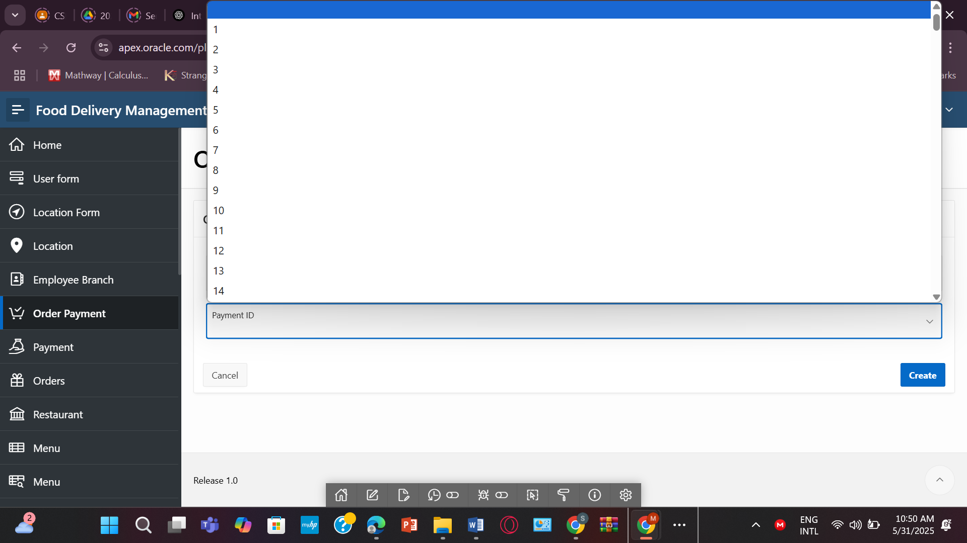

- PAYMENT
CREATE TABLE PAYMENT (
PaymentID NUMBER PRIMARY KEY,
PayID VARCHAR2(100),
Method VARCHAR2(50),
Status VARCHAR2(50),
Phone VARCHAR2(20)
);
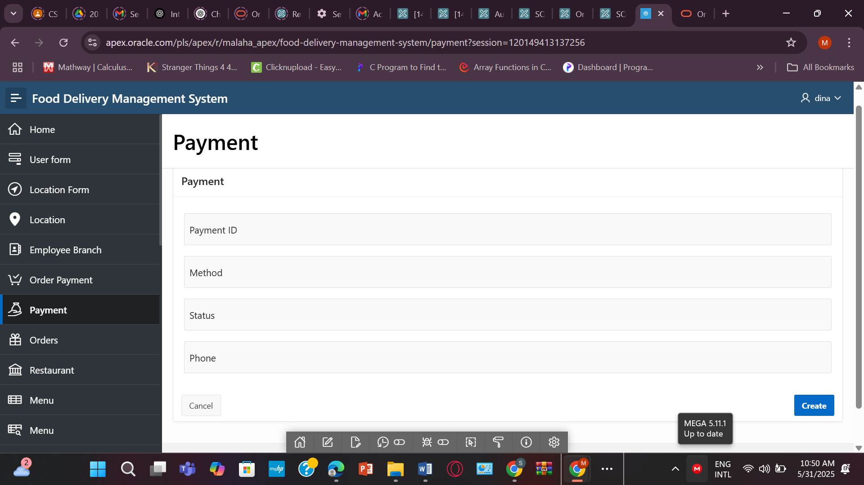

- ORDERS
CREATE TABLE ORDERS (
Order_ID NUMBER PRIMARY KEY,
Order_Status VARCHAR2(50) NOT NULL,
Total_Amount NUMBER(10,2),
Dis_Name VARCHAR2(100),
Payment_Status VARCHAR2(50) NOT NULL,
PolicyID NUMBER,
Cust_ID NUMBER NOT NULL,
CONSTRAINT fk_order_discount FOREIGN KEY (Dis_Name) REFERENCES DISCOUNT(Dis_Name),
CONSTRAINT fk_order_customer FOREIGN KEY (Cust_ID) REFERENCES CUSTOMER(Cust_ID)
);
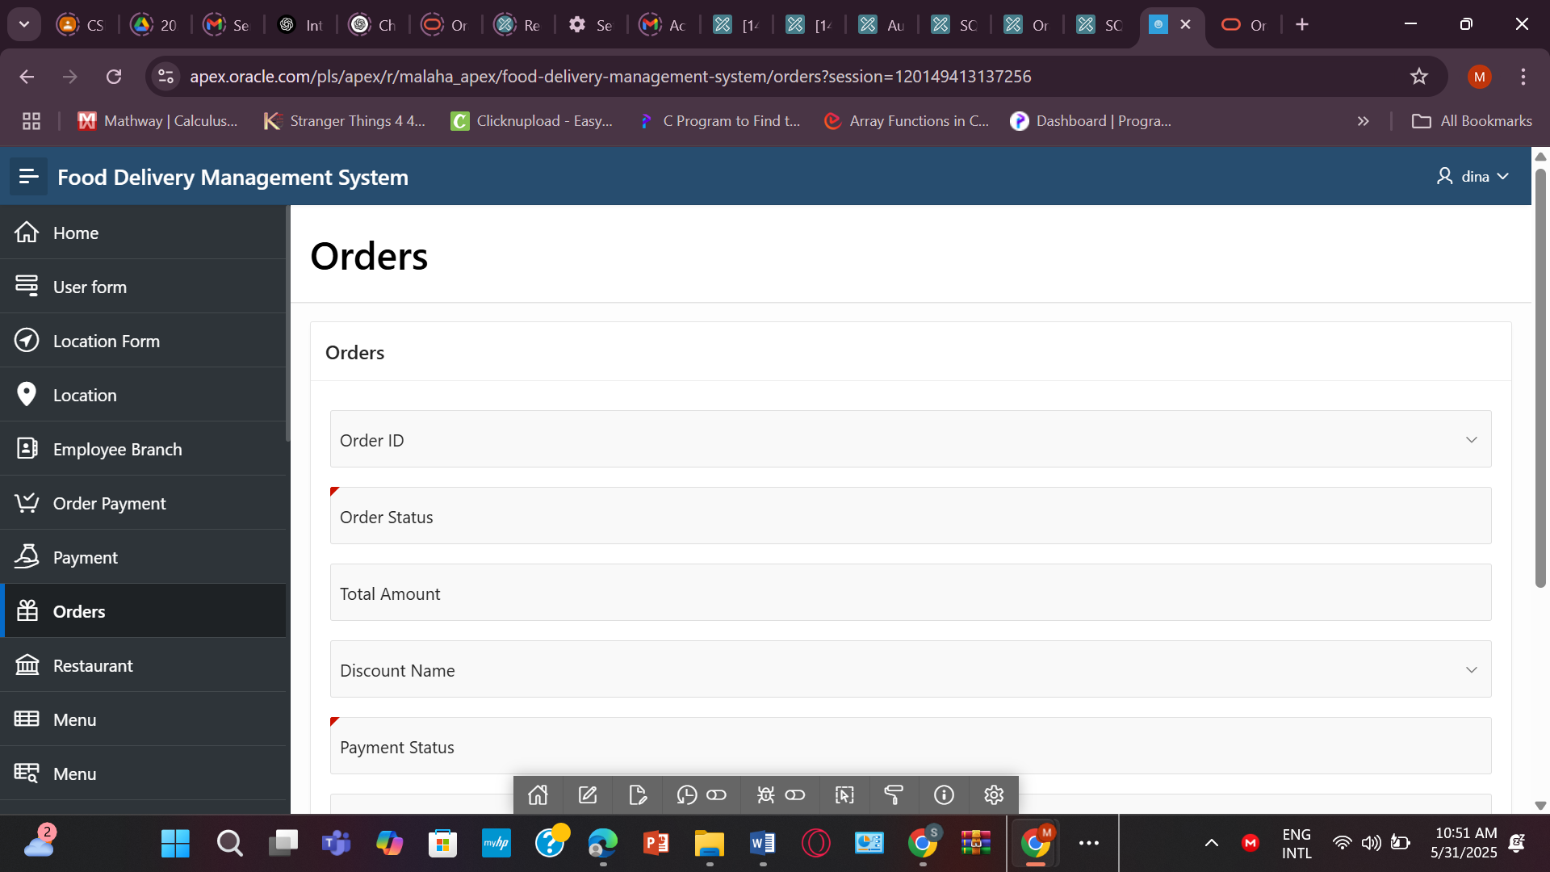

- RESTAURANT
CREATE TABLE RESTAURANT (
Restaurant_ID NUMBER PRIMARY KEY,
Restaurant_Name VARCHAR2(100) NOT NULL,
Owner_Name VARCHAR2(100),
Opening_hours VARCHAR2(50),
R_Rating NUMBER(3,2),
Branch_ID NUMBER NOT NULL,
LocationID NUMBER,
CONSTRAINT fk_restaurant_branch2 FOREIGN KEY (Branch_ID) REFERENCES BRANCH_2(Branch_ID),
CONSTRAINT fk_restaurant_location FOREIGN KEY (LocationID) REFERENCES LOCATION(Location_ID)
);
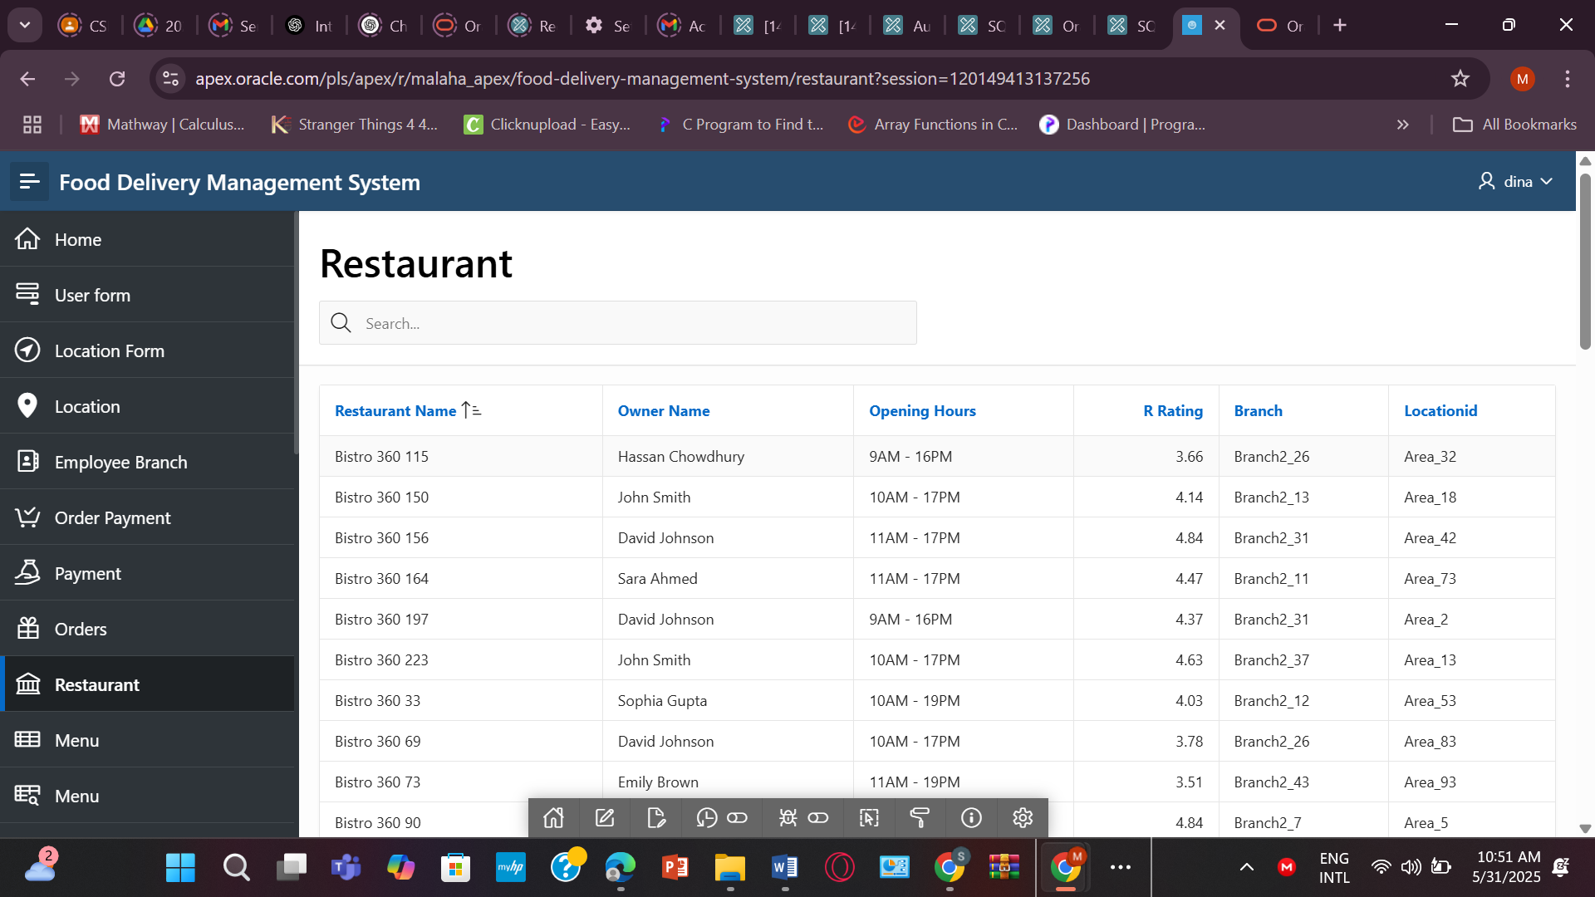

- MENU
CREATE TABLE MENU (
Menu_ID NUMBER PRIMARY KEY,
Menu_Name VARCHAR2(100) NOT NULL,
Category VARCHAR2(50),
Restaurant_ID NUMBER NOT NULL,
CONSTRAINT fk_menu_restaurant FOREIGN KEY (Restaurant_ID) REFERENCES RESTAURANT(Restaurant_ID)
);
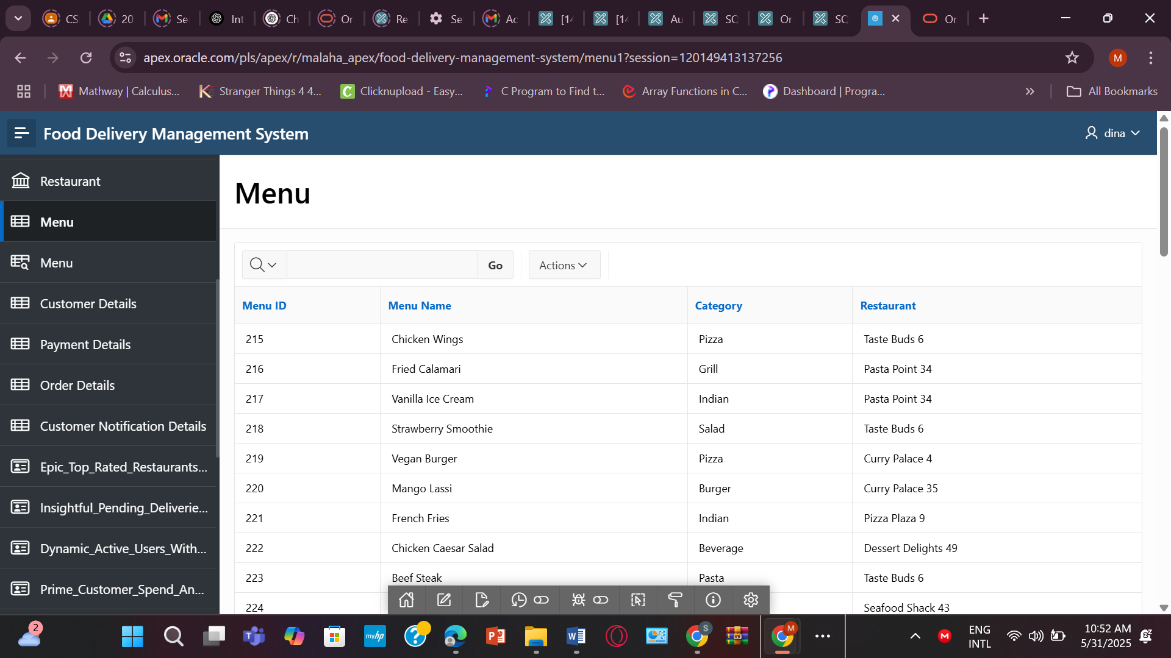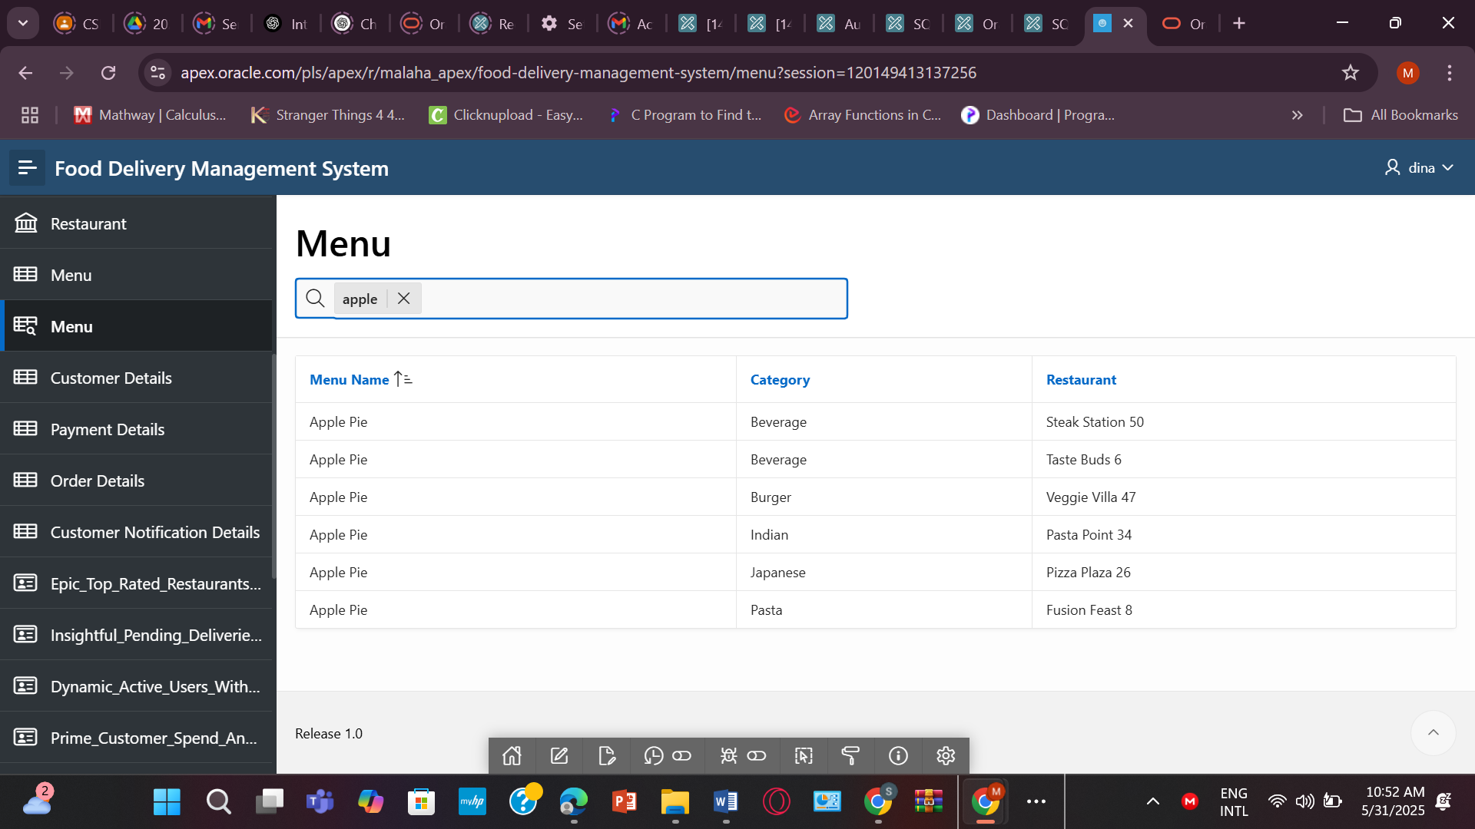

- CUSTOMER
CREATE TABLE CUSTOMER (
Cust_ID NUMBER PRIMARY KEY,
Address VARCHAR2(200),
Bill NUMBER(10,2),
NotificationID NUMBER NOT NULL,
User_ID NUMBER,
CONSTRAINT fk_customer_notification FOREIGN KEY (NotificationID) REFERENCES NOTIFICATION(NotificationID),
CONSTRAINT fk_customer_user FOREIGN KEY (User_ID) REFERENCES USER_(User_ID)
);
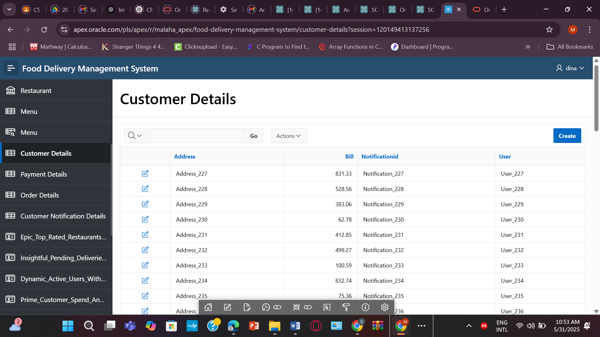

- PAYMENT
CREATE TABLE PAYMENT (
PaymentID NUMBER PRIMARY KEY,
PayID VARCHAR2(100),
Method VARCHAR2(50),
Status VARCHAR2(50),
Phone VARCHAR2(20)
);
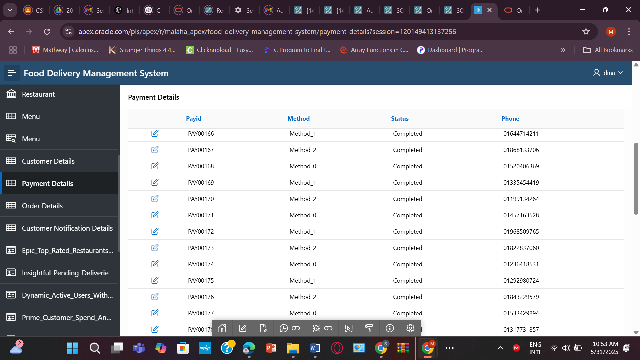

- ORDERS
CREATE TABLE ORDERS (
Order_ID NUMBER PRIMARY KEY,
Order_Status VARCHAR2(50) NOT NULL,
Total_Amount NUMBER(10,2),
Payment_Status VARCHAR2(50) NOT NULL,
PolicyID NUMBER,
CONSTRAINT fk_order_discount FOREIGN KEY (Dis_Name) REFERENCES DISCOUNT(Dis_Name),
CONSTRAINT fk_order_customer FOREIGN KEY (Cust_ID) REFERENCES CUSTOMER(Cust_ID)
);
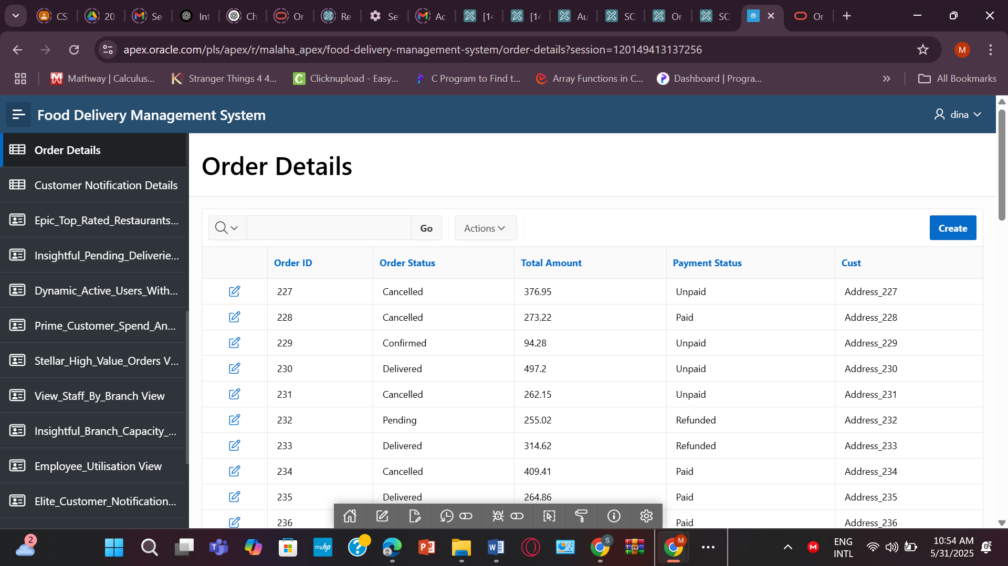

VIEW:
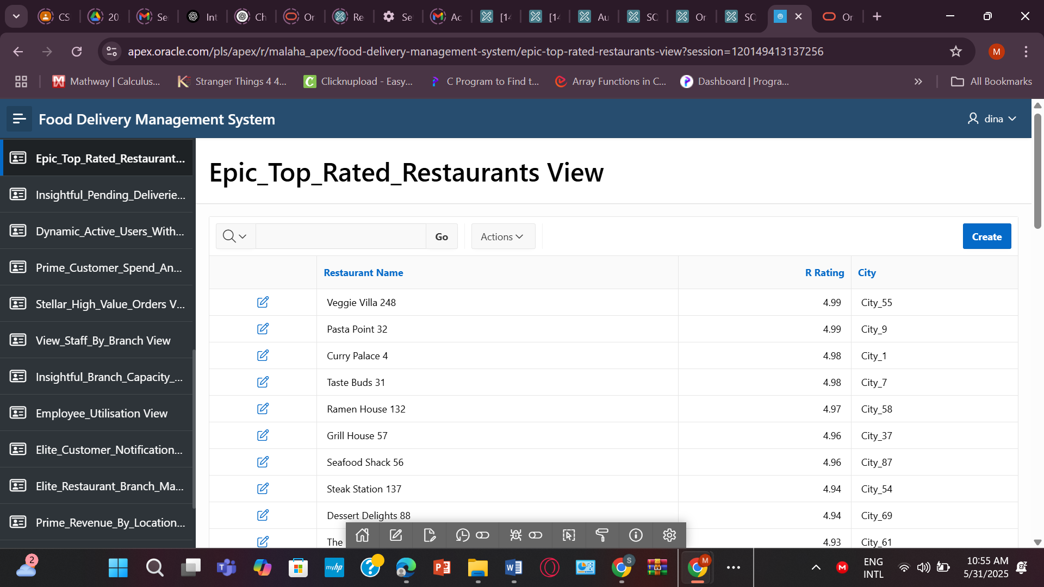
- CREATE OR REPLACE VIEW Epic_Top_Rated_Restaurants AS
SELECT Restaurant_Name, R_Rating, City, Area
FROM RESTAURANT R
JOIN LOCATION L ON R.LocationID = L.Location_ID
WHERE R.R_Rating >= 4.5
ORDER BY R.R_Rating DESC;
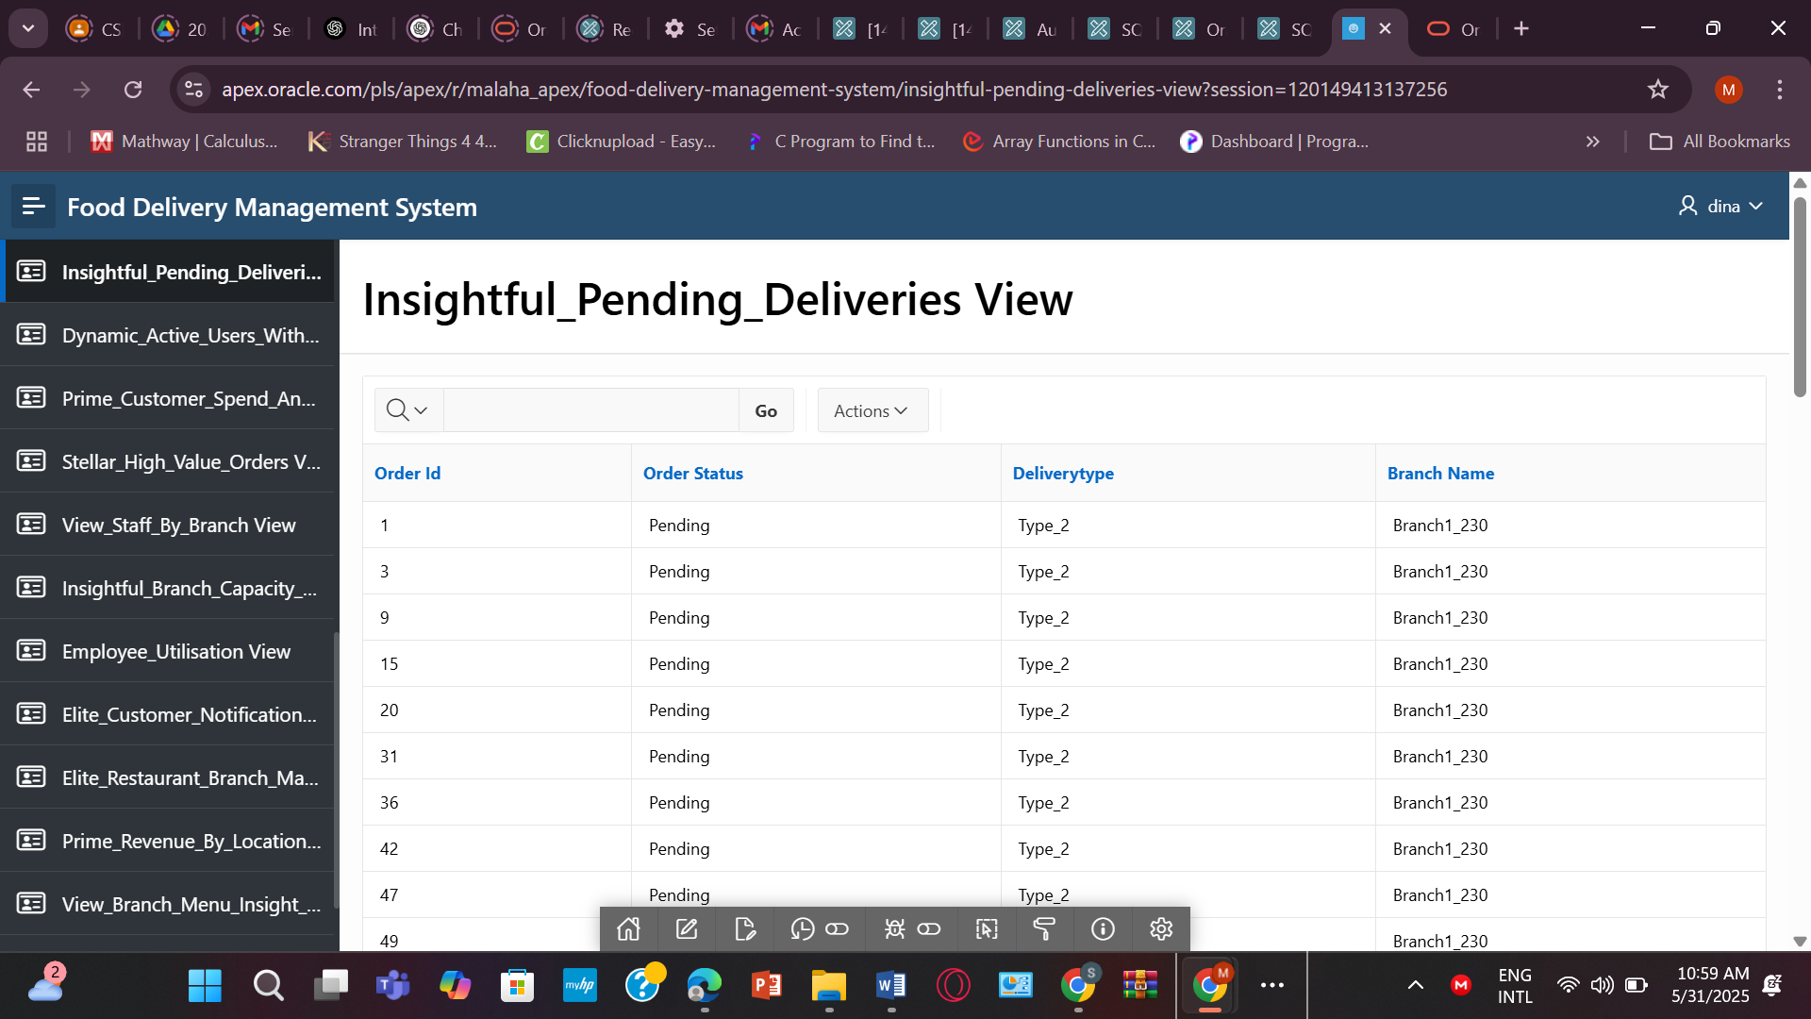
2.CREATE OR REPLACE VIEW Insightful_Pending_Deliveries AS
SELECT
O.Order_ID,
O.Order_Status,
D.DeliveryType,
B.Branch_Name
FROM ORDERS O
JOIN ORDER_PAYMENT OP ON O.Order_ID = OP.Order_ID
JOIN BRANCH_1 B ON O.Cust_ID IS NOT NULL
JOIN DELIVERY D ON D.Branch_ID = B.Branch_ID
WHERE O.Order_Status = 'Pending';
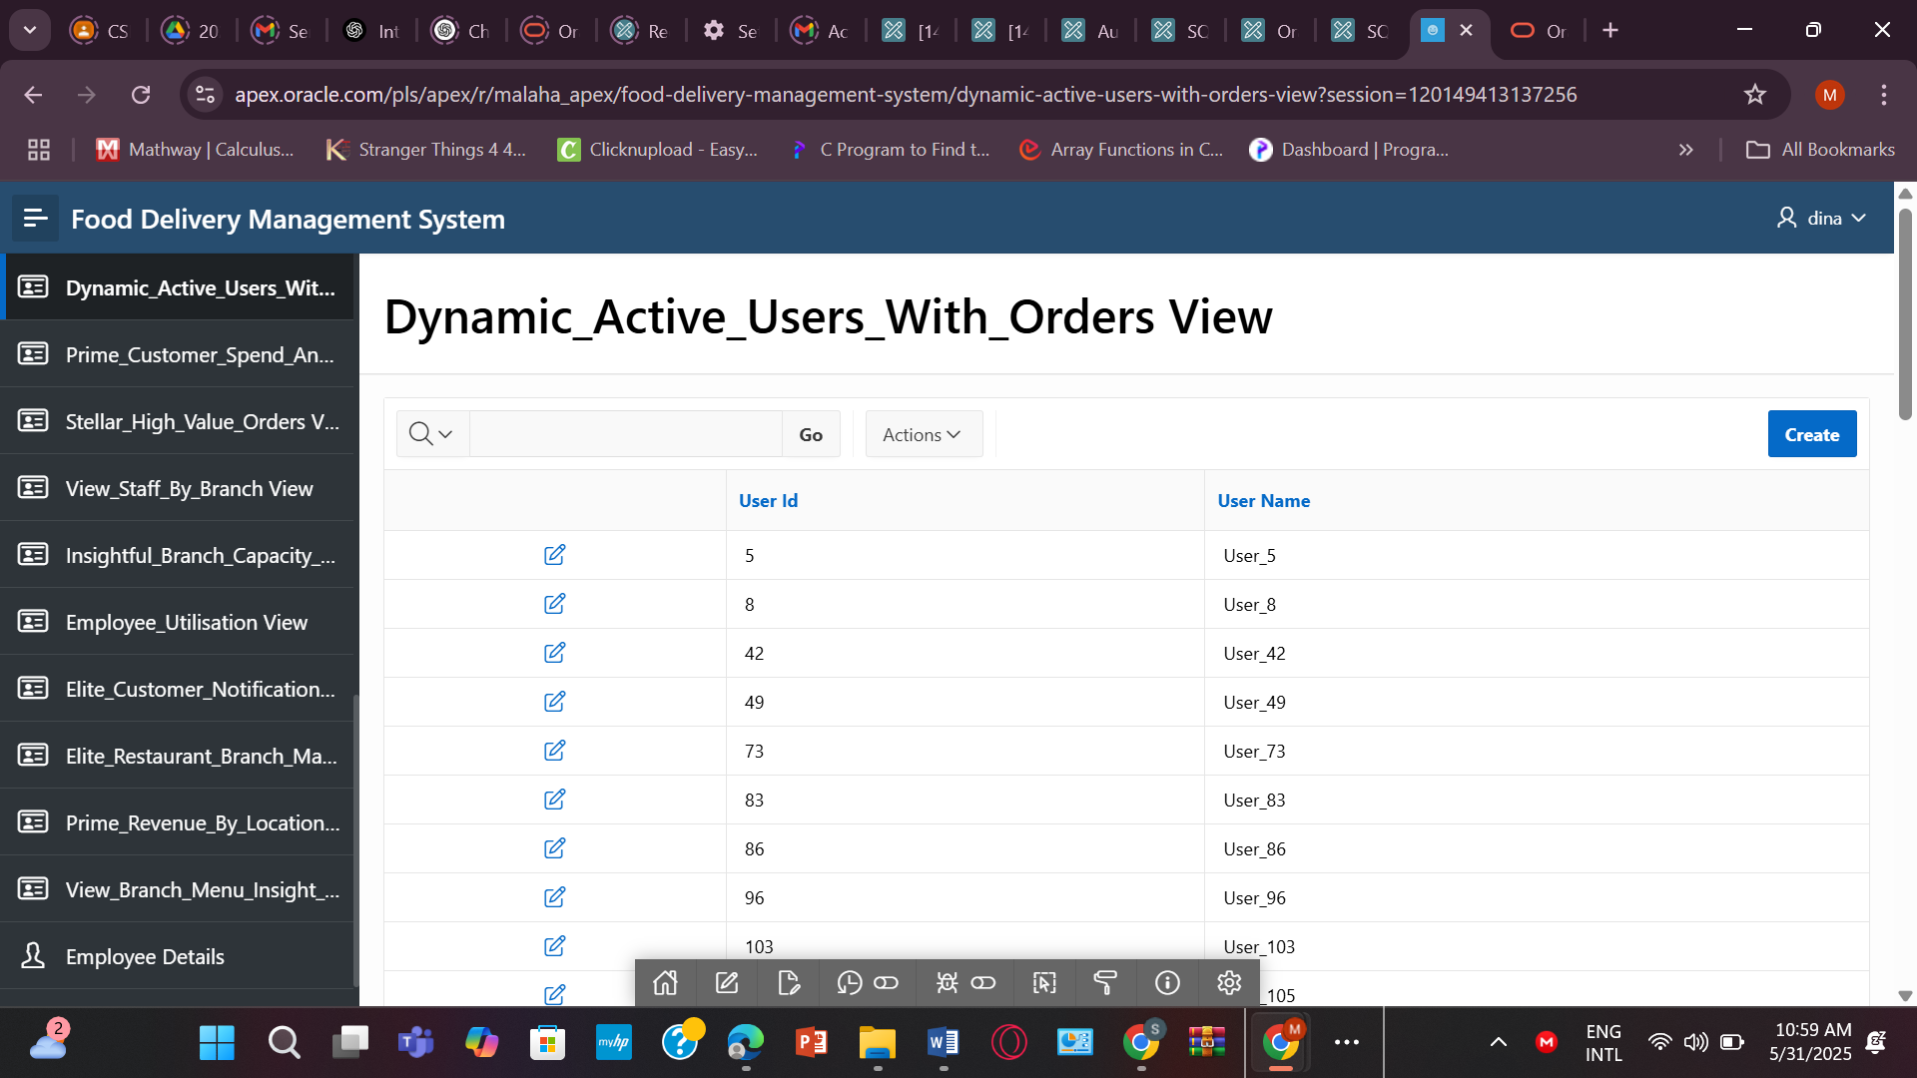
3.CREATE OR REPLACE VIEW Dynamic_Active_USERS_With_Orders AS
SELECT DISTINCT U.User_ID, U.User_Name
FROM USER_ U
JOIN CUSTOMER C ON U.User_ID = C.User_ID
JOIN ORDERS O ON C.Cust_ID = O.Cust_ID;

CREATE OR REPLACE VIEW Stellar_High_Value_Orders AS
SELECT Order_ID, Total_Amount, Payment_Status
FROM ORDERS
WHERE Total_Amount >= 200
ORDER BY Total_Amount DESC;
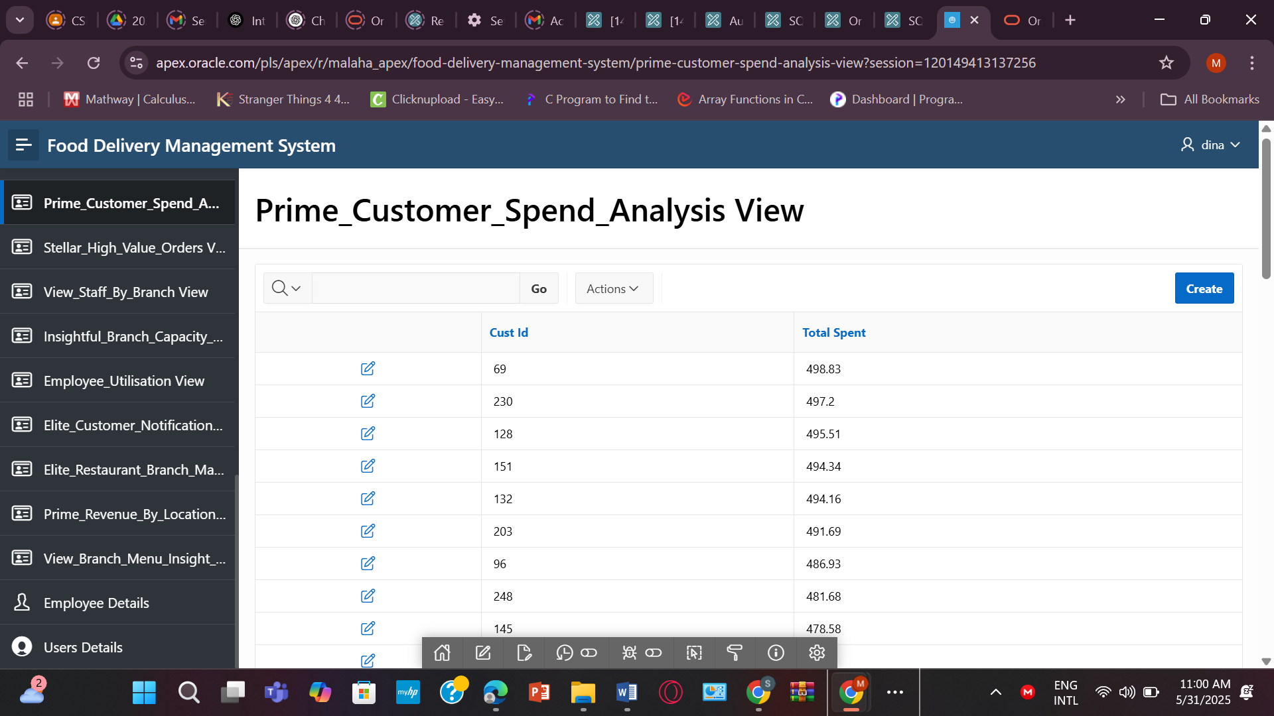
4.CREATE OR REPLACE VIEW Prime_Revenue_By_Location AS
SELECT L.City, L.Area, SUM(O.Total_Amount) AS Total_Revenue
FROM ORDERS O
JOIN CUSTOMER C ON O.Cust_ID = C.Cust_ID
JOIN RESTAURANT R ON C.NotificationID = R.Restaurant_ID
JOIN LOCATION L ON R.LocationID = L.Location_ID
GROUP BY L.City, L.Area
ORDER BY Total_Revenue DESC;
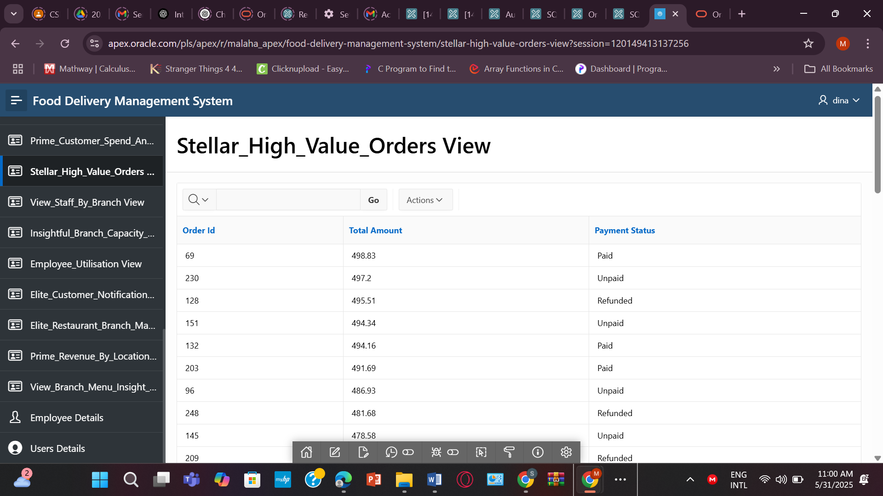
5. CREATE OR REPLACE VIEW Stellar_Employee_Utilisation AS
SELECT Emp_ID, Position, Working_hour, Available_hour,
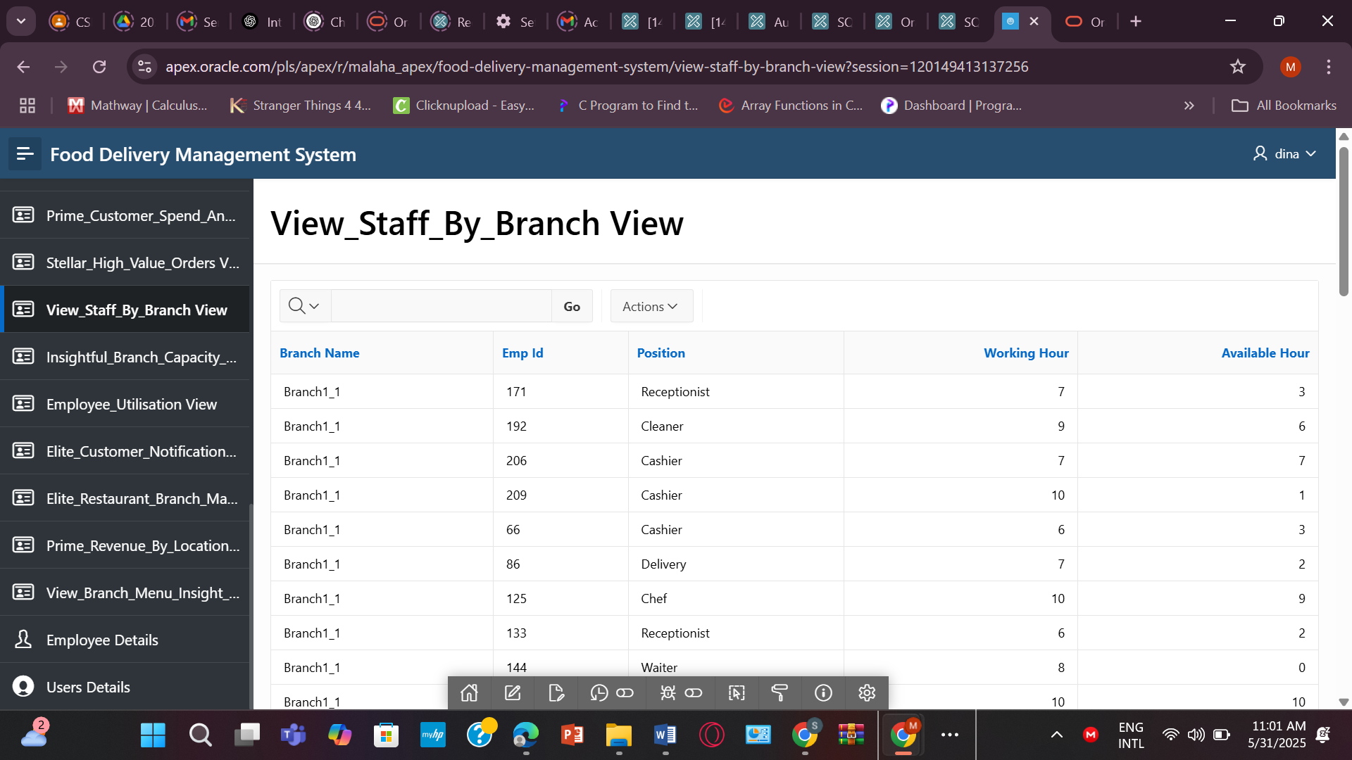
6.CREATE OR REPLACE VIEW View_Staff_By_Branch AS
SELECT
B.Branch_Name,
E.Emp_ID,
E.Position,
E.Working_hour,
E.Available_hour
FROM EMPLOYEE E
JOIN BRANCH_1 B ON E.Branch_ID = B.Branch_ID;
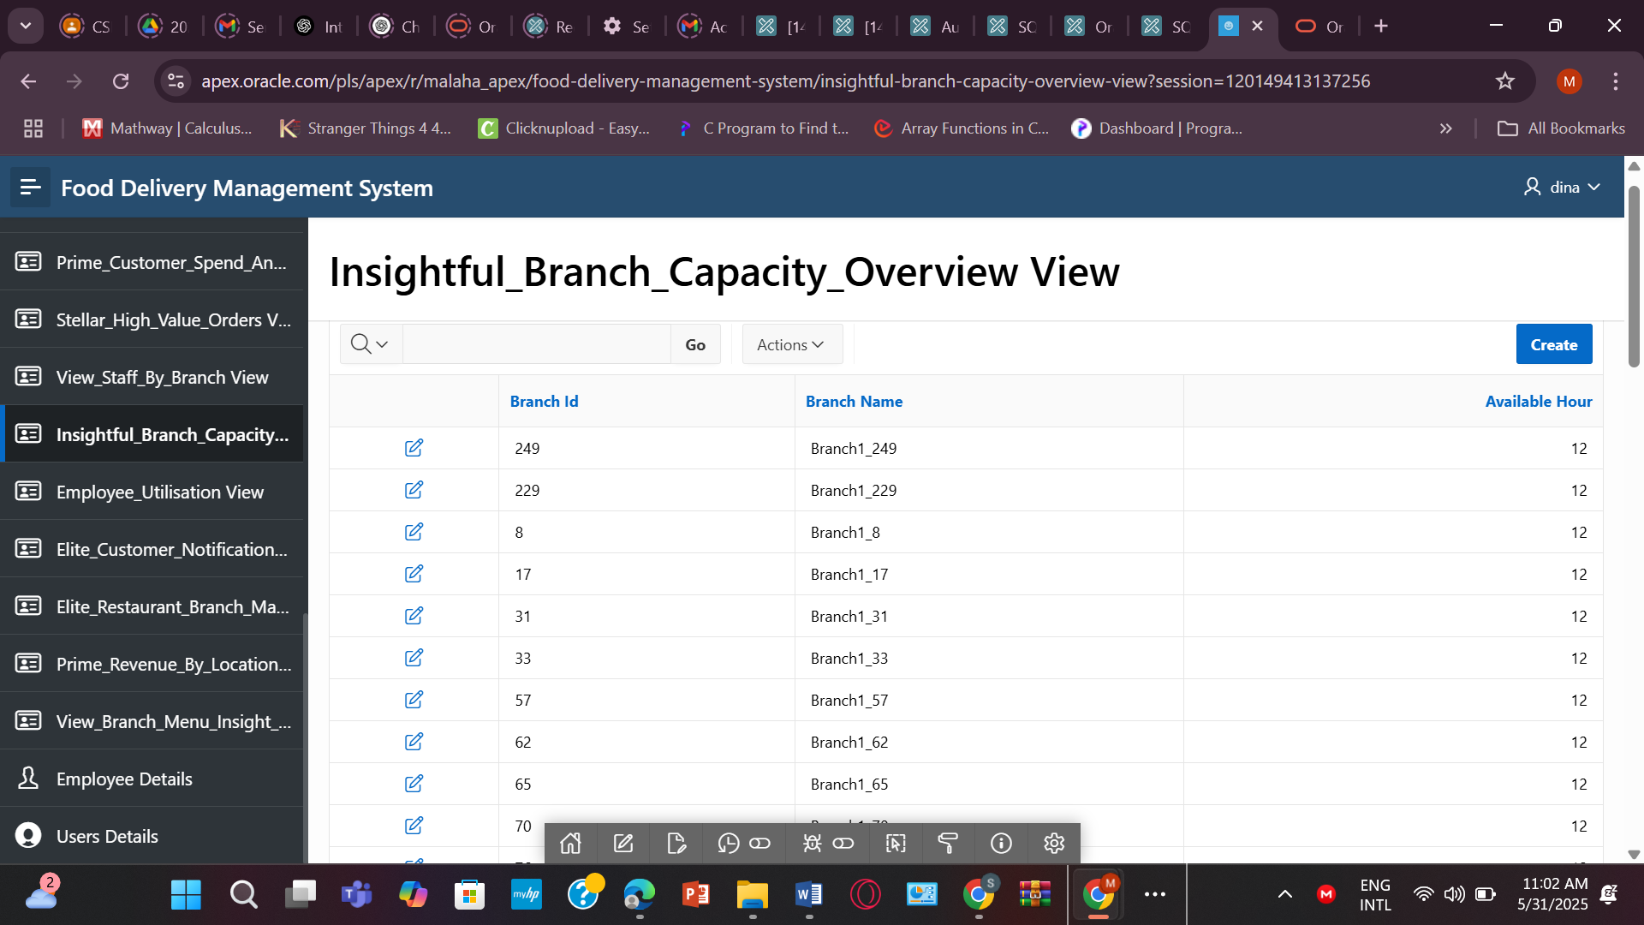
7. CREATE OR REPLACE VIEW Insightful_Branch_Capacity_Overview AS
SELECT Branch_ID, Branch_Name, Available_hour
FROM BRANCH_1
ORDER BY Available_hour DESC;

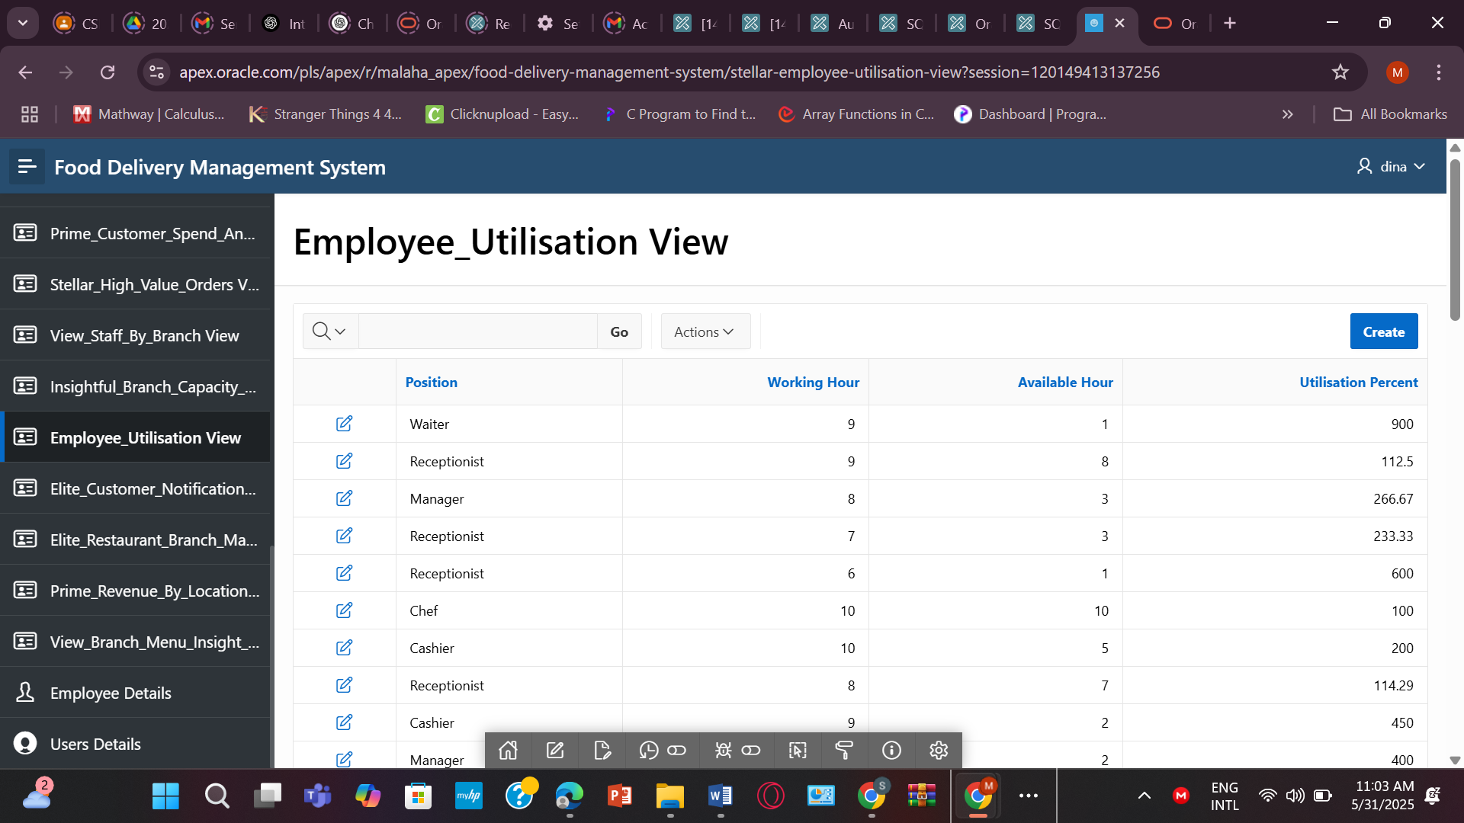
8. CREATE OR REPLACE VIEW Stellar_Employee_Utilisation AS
SELECT Emp_ID, Position, Working_hour, Available_hour,
ROUND((Working_hour/Available_hour)*100, 2) AS Utilisation_Percent
FROM EMPLOYEE
WHERE Available_hour > 0;
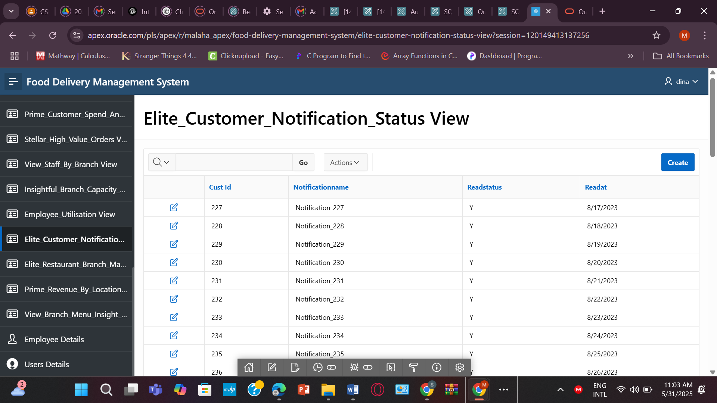
9. CREATE OR REPLACE VIEW Elite_Customer_Notification_Status AS
SELECT CN.Cust_ID, N.NotificationName, CN.ReadStatus, CN.ReadAt
FROM CUSTOMER_NOTIFICATION CN
JOIN NOTIFICATION N ON CN.NotificationID = N.NotificationID;
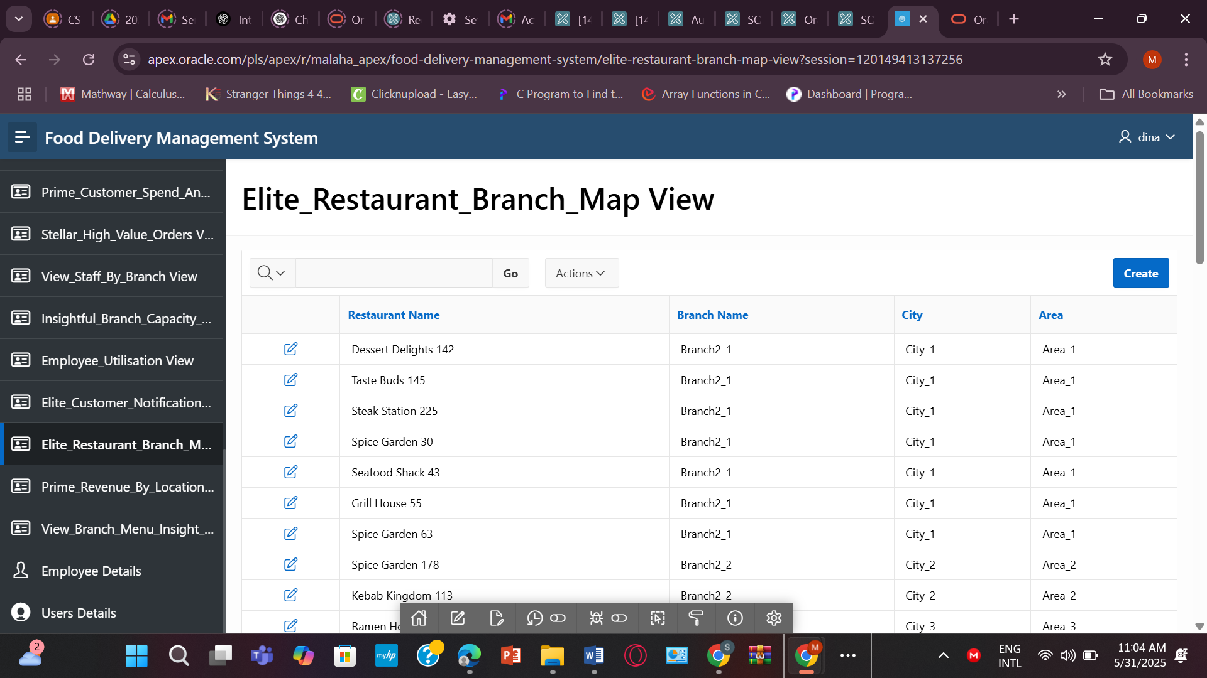
10. CREATE OR REPLACE VIEW Elite_Restaurant_Branch_Map AS
SELECT R.Restaurant_Name, B.Branch_Name, L.City, L.Area
FROM RESTAURANT R
JOIN BRANCH_2 B ON R.Branch_ID = B.Branch_ID
JOIN LOCATION L ON B.Location_ID = L.Location_ID;
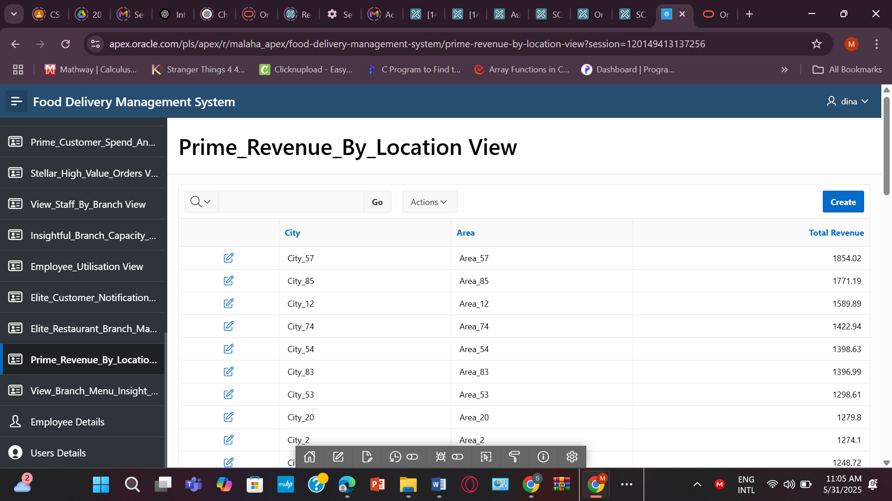
11. CREATE OR REPLACE VIEW Prime_Revenue_By_Location AS
SELECT L.City, L.Area, SUM(O.Total_Amount) AS Total_Revenue
FROM ORDERS O
JOIN CUSTOMER C ON O.Cust_ID = C.Cust_ID
JOIN RESTAURANT R ON C.NotificationID = R.Restaurant_ID
JOIN LOCATION L ON R.LocationID = L.Location_ID
GROUP BY L.City, L.Area
ORDER BY Total_Revenue DESC;
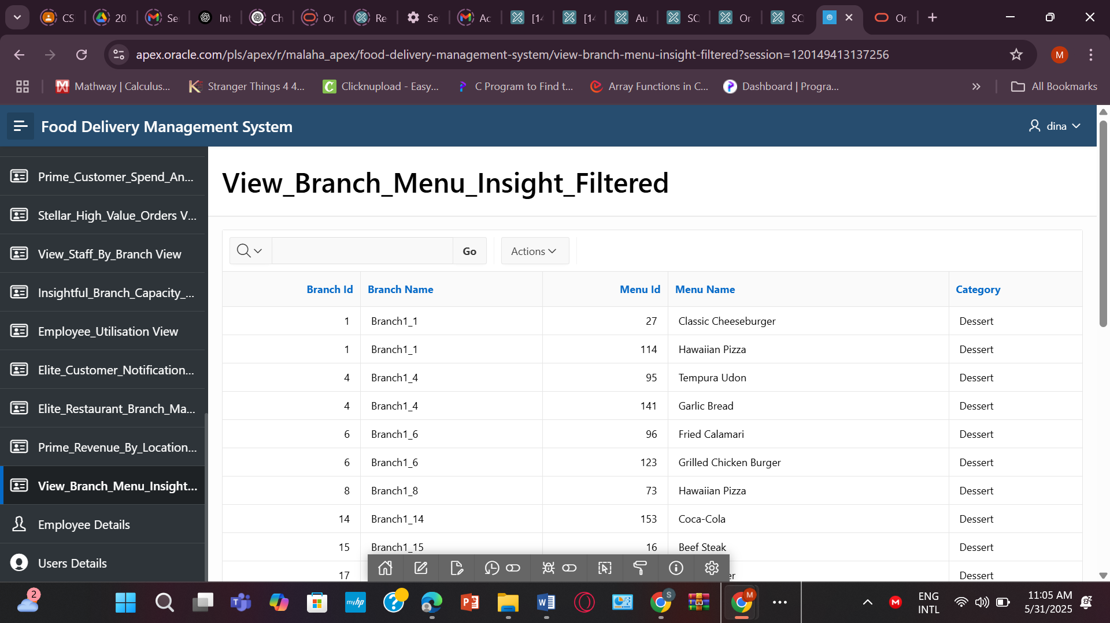
12. CREATE OR REPLACE VIEW View_Branch_Menu_Insight_Filtered AS
SELECT
B.Branch_ID,
B.Branch_Name,
M.Menu_ID,
M.Menu_Name,
M.Category
FROM BRANCH_1 B
JOIN MENU M ON B.Branch_ID = M.Restaurant_ID
WHERE M.Category IN ('Snacks', 'Dessert');

TABLE FORM:
- EMPLOYEE
CREATE TABLE EMPLOYEE (
Emp_ID NUMBER PRIMARY KEY,
Joining_Date DATE NOT NULL,
Salary NUMBER(10,2),
Position VARCHAR2(50),
Working_hour NUMBER,
Available_hour NUMBER,
Branch_ID NUMBER NOT NULL,
User_ID NUMBER,
CONSTRAINT fk_emp_user FOREIGN KEY (User_ID) REFERENCES USER_(User_ID),
CONSTRAINT fk_emp_branch FOREIGN KEY (Branch_ID) REFERENCES BRANCH_1(Branch_ID)
);
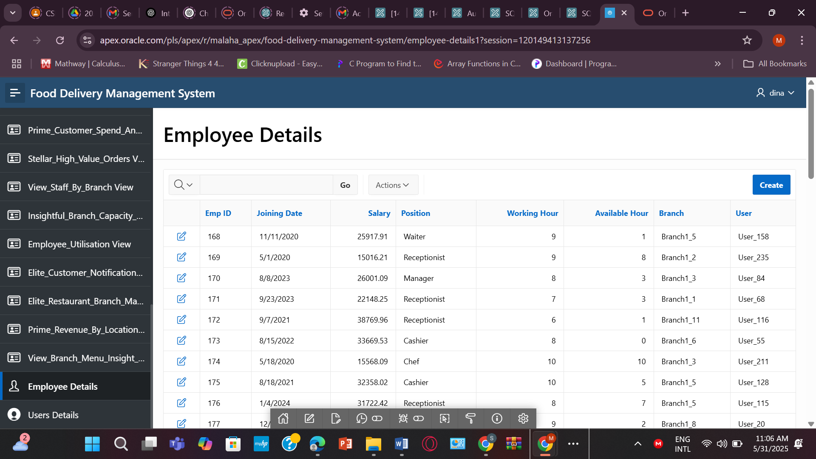

For Authorization & Authentication
CREATE TABLE USERS
( USER_ID INT NOT NULL,
USER_NAME VARCHAR2(100) NOT NULL,
USER_PASS VARCHAR2(100) NOT NULL,
USER_ROLL VARCHAR2(100) NOT NULL,
USER_ACTIVATED NUMBER DEFAULT 0,
PRIMARY KEY (USER_ID)
) ;
INSERT INTO USERS (USER_ID, USER_NAME, USER_PASS, USER_ROLL, USER_ACTIVATED) VALUES (1, 'Pro', 'pro123', 'admin', 1);
INSERT INTO USERS (USER_ID, USER_NAME, USER_PASS, USER_ROLL, USER_ACTIVATED) VALUES (2, 'Dina', 'dina1234', 'user', 1);
